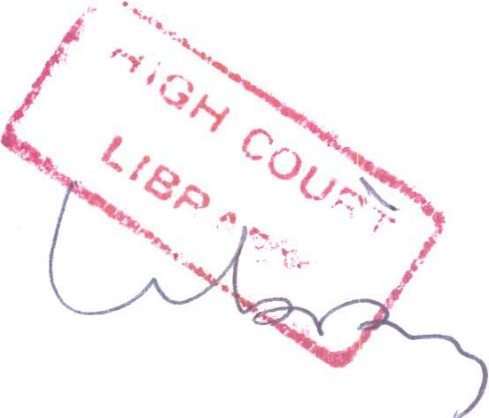

IN THE HIGH COURT OF MALAWI
PRINCIPAL REGISTRY
PERSONAL INJURY CAUSE NUMBER 780 OF 2015

BETWEEN:

ANDSON KABOTOLO AND OTHERS PLAINTIFFS

AND

CHIFUNDO CHIRWA 1st DEFENDANT

REAL INSURANCE COMPANY LTD 2nd DEFENDANT

ENOCK LIKANGA CHIRWA
t/a LIKANGA TRANSPORT 3rd DEFENDANT
CORAM: JUSTICE M.A. TEMBO
Sauti, Counsel for the Plaintiffs
Defendants, absent
Mtegha, Official Court Interpreter

JUDGMENT

This is this court's judgment following a trial of this matter on the plaintiffs' claim for damages for the personal injuries he had suffered due to the alleged negligence on the part of the 1st defendant, who is insured by the 2nd defendant and employed by the 3rd defendant, in the manner he drove a truck and trailer herein resulting in

the said trailer colliding with the motor vehicle m which the plaintiffs were travelling.
The plaintiffs testified at the trial of their claim. The plaintiffs also filed skeleton arguments in support of his claim. The defendants neither brought witnesses in defence nor did they attend trial in this matter despite due notice of the same.
On 2nd August, 2015, the plaintiffs were travelling in a bus on their way back from Mulanje where they went to play social football. As they approached Jac-Jopa furniture shop along the Ml road at Masinde Village, along the Zalewa stretch of the said Ml road, the driver of the bus suddenly saw the truck driven by the 1st defendant in his lane overtaking another vehicle.
The driver of the bus in which the plaintiffs were travelling had to slow down suddenly to avert a head-on collision. He managed just to avoid the head-on collision but the bus collided with the rear end of the truck driven by the 1st defendant.
The standard of proof in these civil matters is on a balance of probabilities as rightly noted by the plaintiffs. And, the burden of proof lies on he who asserts the affirmative, in this case the plaintiff. See Nkuluzado v Malawi Housing Corporation [1999] MLR 302 and Miller v Minister of Pensions [1947] All ER 372.
The plaintiffs rightly submitted on the duties of a driver of a motor vehicle on the road which if breached results in the driver being held liable for negligence and the resultant damage caused by such negligence to those other road users to whom the driver owed the said duties. See Banda and others v ADMARC and another 13 MLR 59, Chuma and another v India and others [1995] MLR 97, Somani and Mulaga v Ngwira 10 MLR 196 and Sagawa v United Transport (Mw) Limited 10 MLR 303.
In the case of Banda and others v ADMARC and another Banda CJ stated succinctly the driver's duty of care to other road users as follows
A driver of a motor vehicle owes a duty of care to other road users not to cause damage to persons, vehicles and property of anyone on or adjoining the road. He must use reasonable care which an ordinary skilful driver would have exercised under all the circumstances. A reasonably skilful driver has been defined as one who avoids excessive speed, keeps a good look-out, observes traffic signs and signals.

The defendants denied the allegation of negligence as stated m the plaintiffs' evidence.
The impression that this Court got from the evidence is that the driver of the bus in which the plaintiffs were travelling herein was indeed lawfully driving on the road in question going in the opposite direction to the truck driven by the 1st defendant.
The 1st defendant then decided to overtake the vehicle in his front, without due regard to the safety of the plaintiffs who were travelling in the vehicle in the opposite direction. In
the end, the 1st defendant created a scenario in which it was inevitable that the bus in which the plaintiffs were travelling collided with part of the trailer of the truck the defendant's insured was driving. This collision resulted in various injuries to the plaintiffs.
In the foregoing circumstances, the 1st defendant breached his duty of care to the plaintiffs, fellow road users, by failing to have a proper look out on the road when overtaking road.
The 1st defendant also failed to comply with section 98 (2) (c) of the Road Traffic Act which prohibits passing other vehicles as follows
The driver of a vehicle shall not pass other traffic proceeding in the same direction on a public road when approaching any other place where his view is so restricted that any such passing could create a hazard in relation to other traffic which might approach from the opposite direction, unless-

(i) he can do so without encroaching on the right-hand side of the roadway; or

(ii) the roadway of such road is restricted to vehicles moving in one direction.section 99 (2) of the Road Traffic Act which prescribes that the driver of a vehicle shall not enter a public road unless he can do so with safety to himself and other traffic .
This Court is satisfied that the plaintiffs have made out their case against the defendants who are liable herein for the 1st defendant's negligent driving that resulted in injury to the plaintiffs herein.
The 2nd defendant is sued and is liable as insurer for the 1st and 3rd defendants.

The plaintiffs having made out the case of negligence against the defendants herein this Court finds the defendants liable for negligence in causing the injuries suffered by the plaintiffs herein.
Damages shall be assessed by the Registrar.

Costs normally follow the event and shall therefore be for the successful plaintiffs. Made in open court at Blantyre this 1st December 2016.

